- Project Planning & Management
- • Project Proposal –
Car rental management system
The Car Rental Project is a platform that connects car owners who want to rent out their vehicles with customers looking to rent a car. The project aims to help car owners benefit from their unused vehicles by earning extra income, while also providing customers with an affordable and convenient transportation option for a specific period without the need to buy a car.
In this way, the project creates a mutually beneficial solution, enabling owners to make use of their cars and allowing customers to easily rent a vehicle at a reasonable price to meet their daily or personal needs.

• Project Plan :
Timeline (Gantt chart)
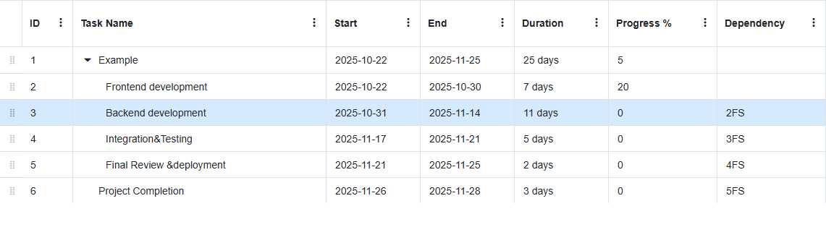
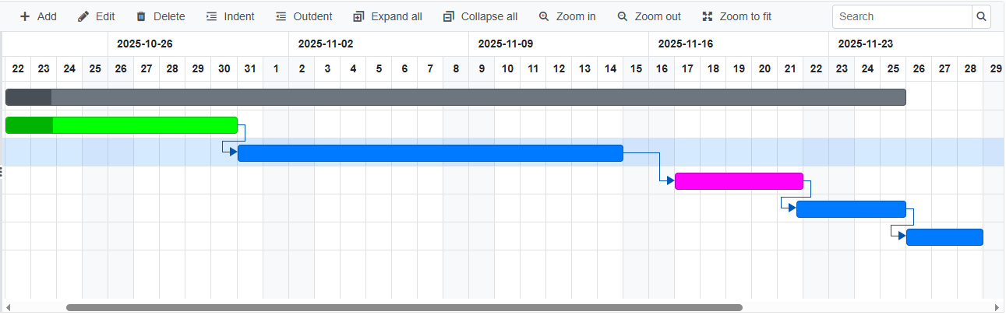
Milestones
Frontend development completion | 30-10-2025
Backend development completion | 14-11-2025
Integration &Testing completion | 21-11-2025
Final Review &Deployment completion | 25-11-2025
Project Completion | 28-11-2025
Deliverables:
Project documentation, Project presentation, Full project source code, Testing reports.
- • Risk Assessment & Mitigation Plan :
Risk | Impact | Solution Plan
Delay in task delivery by some team members | medium
  Create a clear timeline for each task + hold weekly follow-up meetings
 | high
  Errors may occur when connecting the frontend with the backend
  Conduct early testing using Postman
 | high
  Database connection issues
  Use a backup version of the database
Adding overly complex features | high
  Before implementing any new feature, it must be well analyzed and understood through reliable sources such as YouTube tutorials and official documentation. If the feature seems too complex, it should be simplified.

• KPIs
KPI
  Target Value
  Response Time
  ≤ 2 seconds
  System Uptime
  ≥ 99%
 | ≥ 95%
  Booking Success Rate
 | ≥ 85%
  Customer Satisfaction

2. Literature Review
Feedback & Evaluation

Evaluation Summary
During the evaluation phase, it was noted that the current project concept mainly focuses on displaying and renting cars. However, it would be more beneficial if the system aimed to connect car owners who wish to rent out their vehicles with potential renters.
It was also observed that the project could be made more realistic by considering users’ actual needs and enhancing the system’s reliability and accuracy in managing rental operations.

Suggested Improvements
Based on the feedback provided during the evaluation, the following improvements were proposed to further develop the project:
- Develop the project idea into a platform that connects car owners and renters, rather than functioning solely as a car exhibition.
- Add a user identity verification system (for both owners and renters) to ensure safety and credibility.
- Classify cars based on their types and customer needs to make searching and selection easier.
- Clearly define the target audience to ensure services meet user requirements effectively.
- Add a feature to display images of the car before and after the rental process to maintain and document the car’s condition.
- Establish a precise rental system to organize rental operations and prevent conflicts between requests.

Final Grading Criteria

The final evaluation of the project is based on the following criteria and weight distribution:
- Documentation: 20%
- Implementation: 50%
- Testing: 10%
- Presentation: 20%

3. Requirements Gathering
:01Stakeholder Analysis – Identifying Key Stakeholders and Their Needs
1. Admin
The admin manages the entire system including users, cars, bookings, and payments.
Needs: Full access to manage data, generate reports, ensure system security, and monitor transactions efficiently.

2. Car Owner
The car owner lists their vehicles for rent on the platform.
Needs: A secure process to list cars, verify their identity, track rental history, and receive payments safely.

3. Customer (Renter)
The customer uses the platform to rent cars.
Needs: A simple registration and login process, easy car search and booking options, secure payment methods, and accurate rental information.

4. System (Platform)
The system acts as a bridge between car owners and renters.
Needs: To maintain data consistency, ensure information security, and provide smooth interaction between all users.

02 :Functional Requirements
1) User Management Requirements
001: User Registration
Users shall register using their name, phone number, and email.
002: User Login
Users shall log in using username and password.
003: Profile Management
Users shall be able to edit/add:
- Verified ID
- Phone number
- Driving license
- Location
- Date of birth
- Role
- Image
- Gender
004: Booking History
Users shall view their booking history.

2) Car Management Requirements
001: Car Display
System shall display all available cars with:
- Car number
- Model
- Color
- Features
- Description
- Image
- Status (available/rented/under maintenance)
002: Search & Filter
Users shall search and filter cars based on specific criteria.

3) Admin Management Requirements
001: Admin Access
Each admin shall have a personal ID and designation.
002: Car Management
Admins shall add, remove, and edit car information.
003: User Management
Admins shall manage user permissions and view/edit user profiles.
004: Booking Management
Admins shall accept, deny, or cancel rental bookings.
005: Reporting
Admins shall generate reports and perform data analysis.

4) Rental Management Requirements
001: Car Selection
Users shall select an available car and preferred time slot.
002: Status Check
Users shall check the status of selected car.
003: Price Calculation
System shall calculate total rental price automatically.
004: Rental Confirmation
Users shall confirm rental booking.
005: Rental Report
System shall generate a report with a unique rental ID for each reservation.

5) Payment Requirements
001: Payment Methods
System shall support multiple payment methods including:
- Credit card
- Digital wallet
002: Payment Tracking
Each payment shall include:
- Payment ID
- Date
- Method
- Status

6) Optional Features
001: Customer Feedback
Customers shall be able to provide feedback and reviews for rented cars.
002: Customer Support
Customer service support shall be available via chat or message system.

7) Pricing Plan Requirements
001: Price Generation
System shall generate pricing based on:
- Car type
- Model
- Rental duration
- Customer request
- Location
002: Plan Details
Each plan shall include:
- Plan type
- Description
- Rate

8) Rental Process Requirements
001: Pickup Location
Customers shall select a location to receive the car.
002: Contract Generation
System shall automatically generate a contract between the customer and admin.
003: Return Process
Car condition shall be checked and updated upon return.

03 :Non-Functional Requirements
1) Usability Requirements
001: System shall be easy to use with a smooth interface.
002: System shall be simple for all customers to learn and navigate.

2) Performance Requirements
001: System shall handle multiple users simultaneously without lag.
002: Page load time shall be under 3 seconds.

3) Security Requirements
001: Customer information and payment data shall be securely stored and protected.
002: System shall undergo regular vulnerability testing.

4) Scalability Requirements
001: System shall support increasing numbers of cars, users, and transactions without performance degradation.

5) Compatibility Requirements
001: Web application shall be accessible from any device and screen size (desktop, tablet, mobile).

User Stories & Use Cases
1. Customer View
Use Case 1: User Registration and Login
Description: The customer can create an account or log in to access rental services.
Actors:Customer, System
Precondition: The user has access to the website.
Main Flow:
1. The user registers by entering their name, email, and phone number.
2. Alternatively, the user can log in using Gmail or Facebook.
3. If an account already exists, the user logs in using their username and password.
4. The system verifies credentials and grants access.
Postcondition: The user’s account is created or logged in successfully.
User Story:As a customer, I want to register or log in easily so that I can rent cars and manage my account.
Use Case 2: Managing Profile Information
Description: The user can view and update their personal details.
1. The user clicks the Account icon and selects Personal Information.
2. A form appears, allowing the user to upload personal documents (driving license, personal ID).
3. The user can edit or update their profile information and save changes.
Postcondition: Updated personal information is saved and verified.
User Story: As a customer, I want to manage my personal information and documents so that I can complete rental requirements easily.
Use Case 3: Browsing and Searching Cars
Description: The user can browse all available cars and use filters to find specific models.
1. From the homepage, the user views the list of available cars.
2. The user can search or filter by car type, model, price, or availability.
Postcondition: The system displays the matching results.
User Story: As a customer, I want to search and filter cars so that I can quickly find the one that fits my needs.
Use Case 4: Booking a Car
Description: The user can rent a car for a specific period.
1. The user selects a car to rent.
2. Chooses start and end dates and a pickup location.
3. Confirms the rental and proceeds to the payment page.
4. Enters payment information and confirms the transaction.
5. Waits for admin approval of the rental request.
Postcondition:Booking request is submitted and pending admin approval.
User Story: As a customer, I want to rent a car and pay securely so that I can use it for my trip.
Use Case 5: Viewing Booking History
Description:The user can view past bookings.
1. From the profile page, the user selects Booking History.
2. The system displays all previous reservations with details.
Postcondition: Booking history is displayed correctly.
User Story:As a customer, I want to view my past rentals so that I can track my booking records.
Use Case 6: Submitting Reviews
Description:After returning the car, the user can add a review.
1. The user navigates to the rented car’s details page.
2. Submits a rating and feedback.
Postcondition:Review is saved and displayed under the car details.
User Story: As a customer, I want to review my rental experience so that others can make informed choices.
2. Admin View
Use Case 1: Admin Login
Description:Admin logs in using credentials to access administrative features.
User Story: As an admin, I want to log in securely so that I can manage users and cars.
Use Case 2: Managing Users and Bookings
Description: Admin can view, approve, or reject booking requests.
1. Admin reviews rental requests.
2. Approves or denies based on completeness of information.
3. Updates booking status accordingly.
Postcondition: The booking status is updated, and the user is notified.
User Story:As an admin, I want to manage bookings and user requests so that only valid rentals are processed.
Use Case 3: Managing Cars
Description: Admin or car owner can add, edit, or remove cars from the system.
1. Admin accesses the car management panel.
2. Adds a new car or edits/removes an existing one.
3. If a car is unavailable, the system automatically hides it from listings.
Postcondition: Car list is updated accordingly.
User Story: As an admin, I want to manage cars easily so that the system always displays accurate availability.
Use Case 4: Generating Reports
Description: Admin can generate rental and performance reports.
1. Admin opens the report menu.
2. Selects date range or category (e.g., total income, most rented cars).
3. System generates the report.
Postcondition: Reports are displayed or downloaded.
User Story: As an admin, I want to generate analytical reports so that I can monitor business performance

Problem Statement & Objectives :
Car Rental Project is a platform that connects car owners who want to rent out their vehicles with customers looking to rent a car. The project aims to help car owners benefit from their unused vehicles by earning extra income, while also providing customers with an affordable and convenient transportation option for a specific period without the need to buy a car.
In this way, the project creates a mutually beneficial solution, enabling owners to make use of their cars and allowing customers to easily rent a vehicle at a reasonable price to meet their daily or personal needs.
01: Use Case Diagram.
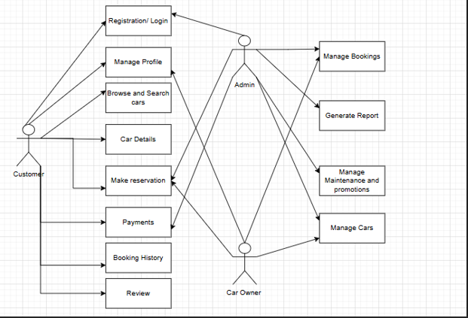

02 :Functional Requirements
1) User Management Requirements
001: User Registration
Users shall register using their name, phone number, and email.
002: User Login
Users shall log in using username and password.
003: Profile Management
Users shall be able to edit/add:
- Verified ID
- Phone number
- Driving license
- Location
- Date of birth
- Role
- Image
- Gender
004: Booking History
Users shall view their booking history.

2) Car Management Requirements
001: Car Display
System shall display all available cars with:
- Car number
- Model
- Color
- Features
- Description
- Image
- Status (available/rented/under maintenance)
002: Search & Filter
Users shall search and filter cars based on specific criteria.

3) Admin Management Requirements
001: Admin Access
Each admin shall have a personal ID and designation.
002: Car Management
Admins shall add, remove, and edit car information.
003: User Management
Admins shall manage user permissions and view/edit user profiles.
004: Booking Management
Admins shall accept, deny, or cancel rental bookings.
005: Reporting
Admins shall generate reports and perform data analysis.

4) Rental Management Requirements
001: Car Selection
Users shall select an available car and preferred time slot.
002: Status Check
Users shall check the status of selected car.
003: Price Calculation
System shall calculate total rental price automatically.
004: Rental Confirmation
Users shall confirm rental booking.
005: Rental Report
System shall generate a report with a unique rental ID for each reservation.

5) Payment Requirements
001: Payment Methods
System shall support multiple payment methods including:
- Credit card
- Digital wallet
- Bank transfer
002: Payment Tracking
Each payment shall include:
- Payment ID
- Date
- Method
- Status

6) Optional Features
001: Customer Feedback
Customers shall be able to provide feedback and reviews for rented cars.
002: Customer Support
Customer service support shall be available via chat or message system.

7) Pricing Plan Requirements
001: Price Generation
System shall generate pricing based on:
- Car type
- Model
- Rental duration
- Customer request
- Location
002: Plan Details
Each plan shall include:
- Plan type
- Description
- Rate

8) Rental Process Requirements
001: Pickup Location
Customers shall select a location to receive the car.
002: Contract Generation
System shall automatically generate a contract between the customer and admin.
003: Return Process
Car condition shall be checked and updated upon return.

03 :Non-Functional Requirements
1) Usability Requirements
001: System shall be easy to use with a smooth interface.
002: System shall be simple for all customers to learn and navigate.

2) Performance Requirements
001: System shall handle multiple users simultaneously without lag.
002: Page load time shall be under 3 seconds.

3) Security Requirements
001: Customer information and payment data shall be securely stored and protected.
002: System shall undergo regular vulnerability testing.

4) Scalability Requirements
001: System shall support increasing numbers of cars, users, and transactions without performance degradation.

5) Compatibility Requirements
001: Web application shall be accessible from any device and screen size (desktop, tablet, mobile).

Software Architecture – High-level design outlining system components, interactions, and architecture style MVC & WebApi
Database Design & Data Modeling:

https://github.com/AsmaaIbrahim-lab/Car-Rental-Management-System/blob/develop/Car_rental_management_system_ERD.drawio
Physical Schema:
https://github.com/AsmaaIbrahim-lab/Car-Rental-Management-System/blob/develop/Car_rental_management_system_Schema.drawio
Data Flow & System Behavior:
Data Flow Diagram (DFD)
Context-Level (Level 0):
At this level, the system interacts with external entities such as:
Customer: Searches available cars, makes rental requests, and completes payments.
Car Owner: Adds and manages cars, views rental requests.
System: Acts as a mediator handling data processing and information exchange between the customer and the car owner.

Level 1 (Detailed Level):

This level breaks down the internal processes and data flow:
User Registration/Login: Handles user account creation and authentication.
Car Management: Allows car owners to add, edit, and manage car information.
Rental Process: Customers request rentals, and the system verifies availability and confirms the rental.
Payment Processing: Manages all payments, updates transaction status, and records payment history.
Report Generation: Automatically creates rental and payment reports for system tracking.
System Behavior (UML Diagrams)
1. Sequence Diagram
Illustrates the order of communication between system components:
Customer logs in.
Customer requests a car rental.
System checks car availability.
Car owner receives a rental request notification.
Owner confirms the request.
System processes the payment and confirms the rental.
2. Activity Diagram
Shows the main workflow of the system:
User login.
Browse available cars.
Select car and rental duration.
Confirm rental.
Make payment.
Generate and view rental report.
3. State Diagram
Represents different states of a car during the rental process:
Available → Rented → Returned → Under Maintenance → Available again

4. Class Diagram

Defines the main structural components of the system, including classes, attributes, and relationships:
User: Manages login and account information (UserName, Password, Role, Email).
Customer: Represents users who rent cars (Name, Age, Gender, Phone, Location).
CarOwner: Represents users who list cars for rent.
Car: Stores car details (Model, Color, Number, Status, Location).
Rental: Tracks rental transactions (StartDate, EndDate, FinalAmount, Status).
Payment: Handles financial transactions (PaymentDate, Amount, Method, Status).
Report: Generates summaries of rentals and payments

UI/UX Design & Prototyping • Wireframes & Mockups – Screens and visual representations of the user interface. :
This is visualisation inspiration for our project:

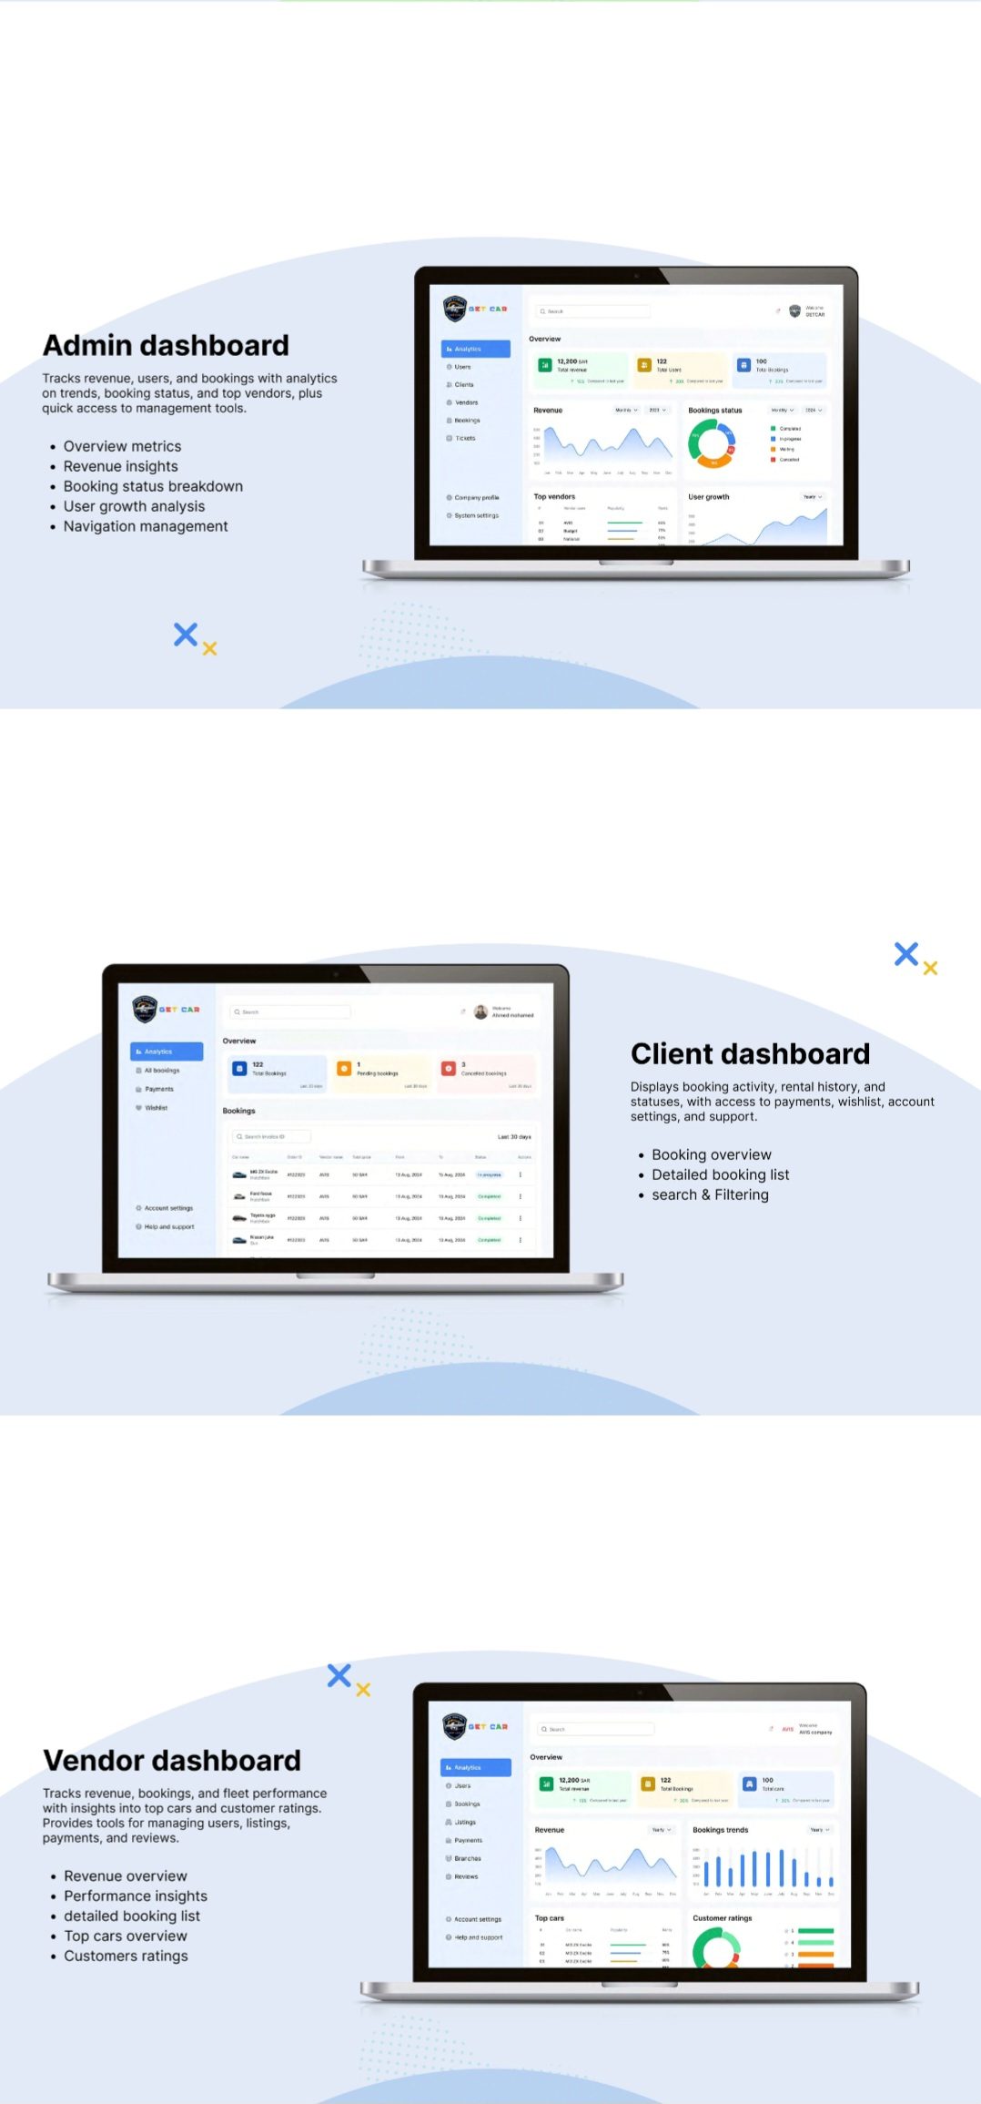
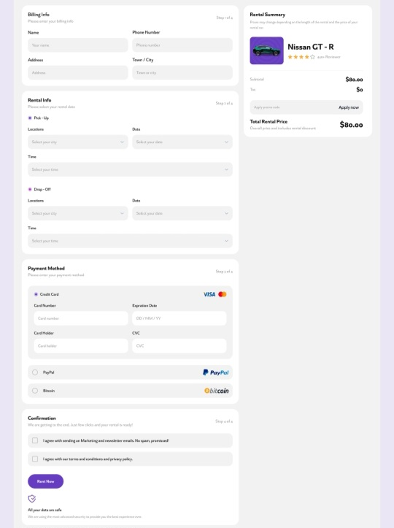
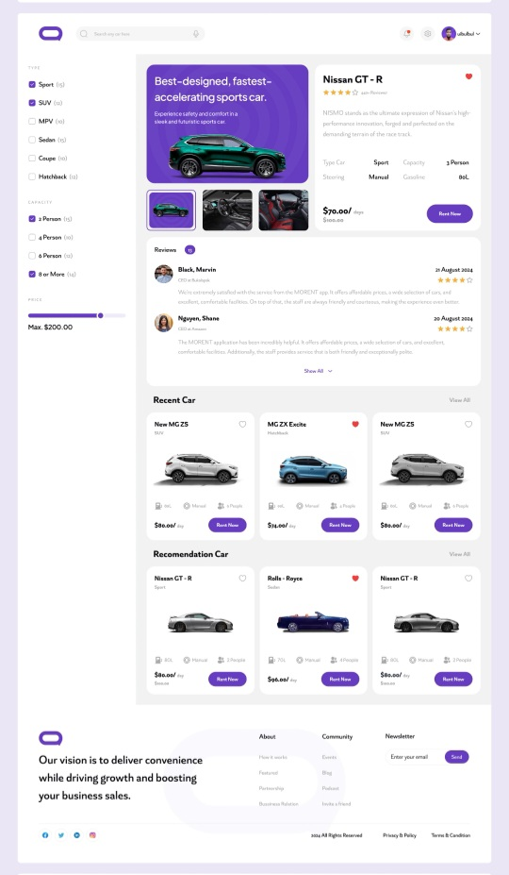

Wireframes of our project visualisation:
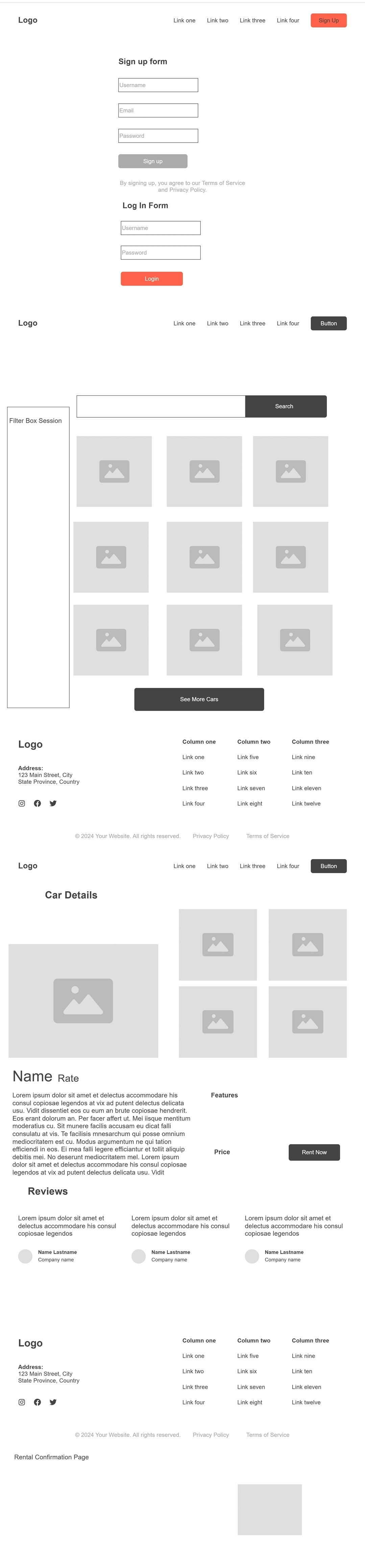
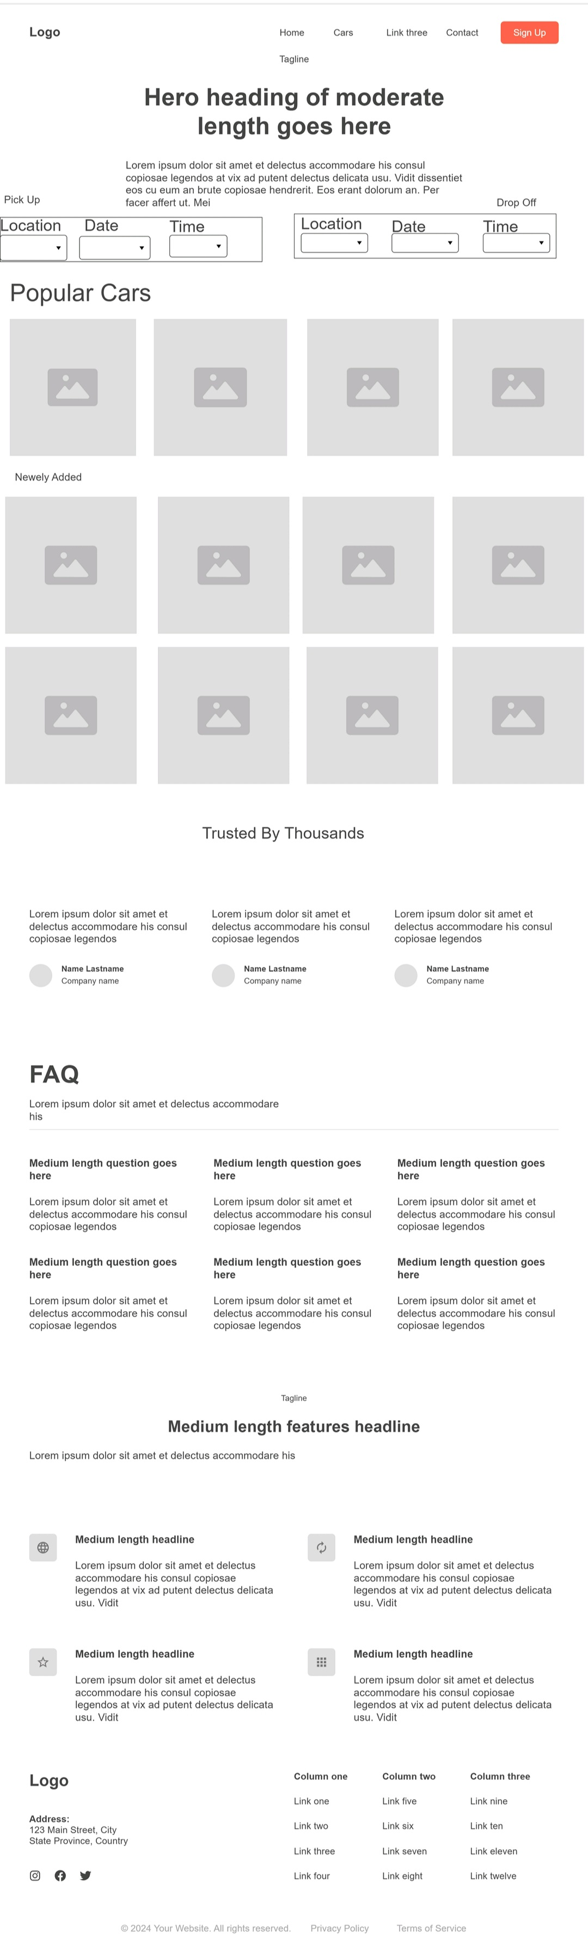

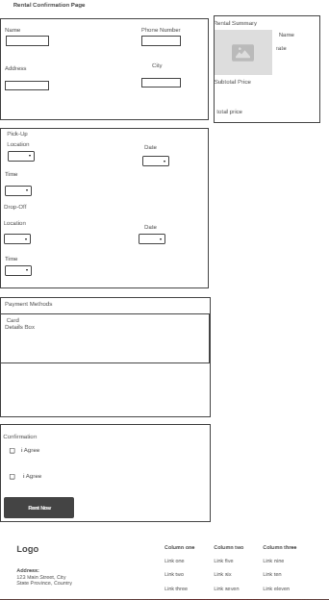

UI/UX Guidelines – Design principles, color schemes, typography, and accessibility considerations:
UI/UX Requirements

- Design Principles

The design of the Car Rental System will follow modern UI/UX best practices to ensure an intuitive and engaging user experience.

Simplicity: The interface will remain clean and easy to navigate, focusing on essential actions such as browsing cars, checking availability, and making bookings.

Consistency: Colors, buttons, and layout patterns will be consistent across all pages to provide a smooth user journey.

Visual Hierarchy: Important elements such as car names, prices, and “Book Now” buttons will be highlighted through size, color, and placement to draw the user’s attention.

Feedback: The system will give clear visual and textual feedback for user actions, such as success messages when a booking is completed or error alerts for invalid input.

Responsiveness: The design will be fully responsive and optimized for desktop, tablet, and mobile screens.

User-Centered Design: Every screen and element is designed with the user in mind — prioritizing ease of use, clarity, and quick access to key features.

Color Scheme

The color palette for the Car Rental System is designed to create a modern, professional, and trustworthy interface.

It combines energetic tones for interactive elements with clean neutrals for background and readability.

Additional color indicators are defined for the Admin and User Dashboards to help users easily distinguish system statuses.

Main Website Colors

Purpose Color Description

Primary Color #FFA726 (Light Orange) Used for main buttons, links, and key highlights such as “Book Now”. Represents friendliness and energy.

Secondary Color #0D47A1 (Dark Blue) Used for secondary buttons and navigation bars to convey trust and professionalism.

Background Color #F5F5F5 (Light Gray) Clean, neutral background for forms, cards, and pages.

Text Color #333333 (Dark Gray) Ensures high readability and contrast against light backgrounds.

Accent Colors #29B6F6 (Sky Blue), #43A047 (Green), #E53935 (Red) Used for hover effects, icons, and section highlights.

Status Colors Success: #28A745 (Green), Error: #DC3545 (Red) Used in alert messages and feedback notifications.

Admin Dashboard Colors

Purpose Color Description

Dashboard Background #E3F2FD (Light Blue) Soft background to keep focus on data elements.

Cards / Widgets #FFFFFF (White) Clean layout for clarity of data visualization.

Active / Selected Items #0D47A1 (Dark Blue) Highlights selected sections or tabs.

Total Count Indicator #2196F3 (Blue) Represents total values or overall data summaries.

Pending Status #FFA726 (Orange) Used for pending or under-review records.

Canceled Status #E53935 (Red) Indicates canceled or rejected actions.

Completed Status #43A047 (Green) Represents completed transactions or approved records.

User Dashboard Colors

Purpose Color Description

In Progress Status #2196F3 (Blue) Used for ongoing bookings or active rentals.

Completed Status #43A047 (Green) Shows successfully completed rentals or actions.

Pending Status #FFA726 (Orange) Indicates reservations awaiting confirmation.

Canceled Status #E53935 (Red) Used for canceled or expired bookings.

Summary

The chosen color scheme creates a clear visual hierarchy and improves usability across all sections of the system.

Orange and blue tones highlight important actions and statuses.

Green and red provide clear feedback for completed or failed actions.

Light blue and gray backgrounds ensure a calm, modern interface.

- Typography

Typography plays a key role in maintaining clarity and readability across the interface.

Element Font Family Style / Size Purpose

Headings (H1–H3) Poppins, sans-serif Bold, 24–32px For section titles like “Available Cars” or “Booking Details.”

Subheadings (H4–H6) Poppins, sans-serif Medium, 18–22px For labels and smaller titles.

Body Text Open Sans, sans-serif Regular, 14–16px For descriptions, details, and paragraphs.

Buttons Poppins, sans-serif Bold, 14px, Uppercase For clarity and emphasis on actions.

This combination of Poppins and Open Sans provides a modern, clean, and readable visual style suitable for both desktop and mobile devices.

- Accessibility Considerations

The design will ensure that the system is usable and accessible for all users, following WCAG (Web Content Accessibility Guidelines).

Color Contrast: Text and backgrounds maintain a contrast ratio of at least 4.5:1 for readability.

Alt Text: All images (such as car photos) include descriptive alt text for screen readers.

Keyboard Navigation: Users can navigate the entire system using a keyboard without requiring a mouse.

Form Accessibility: All input fields have clear labels and error messages to guide users.

Responsive Design: The layout automatically adjusts for mobile, tablet, and desktop screens.

These measures ensure that the system is inclusive and easy to use for people with different abilities and devices

• Technology Stack – Backend(MVC,WebApi), frontend(HTML,CSS,JavaScript,Bootstrap,Jquery), and database technologies(SQL Server ).

• Component Diagram:
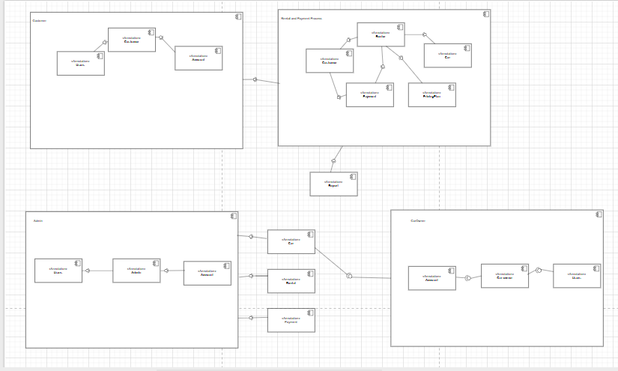

Deployment Diagram :
